

Requirement & Design Specification

**Global Access Management System (GAMS)**

**Version: 1.0**

– Ho Chi Minh Campus, 2024 –

# Record of Changes

| **Version** | **Date** | **A* M, D** | **In charge** | **Change Description** |
| --- | --- | --- | --- | --- |
| V1.0 | 15/2 | A | KienNTHE11 |  |
|  |  |  |  |  |
|  |  |  |  |  |
|  |  |  |  |  |
|  |  |  |  |  |
|  |  |  |  |  |
|  |  |  |  |  |
|  |  |  |  |  |
|  |  |  |  |  |
|  |  |  |  |  |
|  |  |  |  |  |
|  |  |  |  |  |

*A - Added M - Modified D - Deleted

Contents

Record of Changes 2

I. Overview 4

1. User Requirements 4

1.1 Actors 4

1.2 Use Cases 4

2. Overall Functionalities 5

2.1 Screens Flow 5

2.2 Screen Descriptions 5

2.3 Screen Authorization 5

2.4 Non-UI Functions 6

3. System High Level Design 6

3.1 Database Design 6

3.2 Code Packages 7

II. Requirement Specifications 8

1. <<Feature Name>> 8

1.1 <<UseCaseCode_UC Name>> 8

2. Common Functions 11

2.1 UC-2_Login System 11

3. Patron Feature 12

3.1 UC-5_Order a Meal 12

3.2 UC-6_Register for Payroll Deduction 13

III. Design Specifications 14

1. <<Feature Name>> 14

1.1 <<SubFeature Name>> 14

1.2 System Access 15

IV. Appendix 19

1. Assumptions & Dependencies 19

2. Limitations & Exclusions 19

3. Business Rules 19

4. .. 19

# I. Overview

## 1. User Requirements

### 1.1 Actors

| **#** | **Actor** | **Description** |
| --- | --- | --- |
| 1 | Guest | Users who have not logged in the web application |
| 2 | Customer | Users who have logged in the web application |
| 3 | Staff | User who have manage products and orders of user |
| 4 | Suppliers | User who have provide products for sale or rent |
| 5 | Admin | User who can manage system |

### 1.2 Use Cases

### **Use Cases for Suppliers**

1. **Add Toy to Inventory  
   Description**: Supplier adds new toys to the inventory for rent or sale.  
   **Actors**: Supplier  
   **Outcome**: Toy is listed on the platform for users to rent or purchase.
2. **Update Toy Information  
   Description**: Supplier edits the details of a toy (price, description, availability).  
   **Actors**: Supplier  
   **Outcome**: Updated toy details are reflected on the platform.
3. **Fulfill Rental Request  
   Description**: Supplier processes a rental request by preparing and shipping the toy to the user.  
   **Actors**: Supplier  
   **Outcome**: Toy is shipped to the user, and the inventory is updated.
4. **Update Rental Status  
   Description**: The system updates the rental status of a toy based on the current transaction.  
   **Actors**: Supplier  
   **Outcome**: The rental status of the toy is successfully updated
5. **Prepare Toys for Delivery  
   Description**: The supplier prepares toys for delivery after a user has rented or purchased them.  
   **Actors**: Supplier  
   **Outcome**: The toy is ready for delivery and marked accordingly in the system.

### **Use Cases for Staff**

1. **Verify Rental/Sales Requests  
   Description**: Staff reviews and verifies user requests for renting or purchasing toys.  
   **Actors**: Staff  
   **Outcome**: Approved or rejected requests are processed.
2. **Manage User Support Queries  
   Description**: Staff handles and resolves user queries related to rentals, purchases, or platform issues.  
   **Actors**: Staff  
   **Outcome**: Users receive assistance, and their issues are resolved.
3. **Track and Manage Toy Deliveries  
   Description**: Staff oversees the delivery process for rented or sold toys.  
   **Actors**: Staff  
   **Outcome**: Toys are tracked and delivered on time, with status updates provided.
4. **Handle Refund and Cancellation Requests  
   Description**: Staff manages refund or cancellation requests for rentals or purchases.  
   **Actors**: Staff  
   **Outcome**: Refunds are issued or orders are canceled as per policy.
5. **Monitor User Feedback and Complaints  
   Description**: Staff monitors user feedback, ratings, and complaints about toys or suppliers.  
   **Actors**: Staff  
   **Outcome**: User feedback is used to improve service and supplier accountability.
6. **Coordinate with Suppliers for Toy Availability  
   Description**: Staff coordinates with suppliers to ensure toys are available for requested rentals or purchases.  
   **Actors**: Staff  
   **Outcome**: Toy availability is updated, and suppliers are notified of demand.
7. **Resolve Delivery Issues  
   Description**: Staff resolves issues related to delivery delays, damaged toys, or incorrect deliveries.  
   **Actors**: Staff  
   **Outcome**: Delivery issues are addressed, and users are informed of resolutions.

### **Use Cases for Admin**

1. **Manage Suppliers  
   Description**: Admin manages the list of registered suppliers and can add, update, or deactivate suppliers.  
   **Actors**: Admin  
   **Outcome**: Supplier list is kept up-to-date and compliant with platform standards.
2. **Approve New Toy Submissions  
   Description**: Admin reviews and approves new toys submitted by suppliers before they are listed.  
   **Actors**: Admin  
   **Outcome**: Approved toys appear on the platform for rent or sale.
3. **Track Revenue and Financial Performance  
   Description**: Admin monitors platform earnings, supplier payouts, and overall financial performance.  
   **Actors**: Admin  
   **Outcome**: Financial transparency is maintained, and earnings are tracked.
4. **Manage User Accounts  
   Description**: Admin oversees user accounts, including registration approvals, suspensions, and terminations.  
   **Actors**: Admin  
   **Outcome**: The user base is managed, ensuring compliance and system integrity.
5. **Review System Usage Reports  
   Description**: Admin generates and reviews reports on platform usage (rentals, sales, earnings, etc.).  
   **Actors**: Admin  
   **Outcome**: Reports provide insights into platform performance and user activity.
6. **Configure Platform Settings  
   Description**: Admin manages platform settings, including notifications, security policies, and maintenance schedules.  
   **Actors**: Admin  
   **Outcome**: The platform operates smoothly and securely, with regular updates and backups.
7. **Manage Promotions and System-Wide Discounts  
   Description**: Admin configures and oversees system-wide promotions, such as discounts for special events or holidays.  
   **Actors**: Admin  
   **Outcome**: Promotions are applied across the platform, boosting user engagement.

### **Use Cases for Customers**

1. **Browse Toys**

**Description**: Customers can view and search for available educational toys on the platform.

**Actors**: Customer

**Outcome**: Customers can easily find toys that meet their needs for rent or purchase.

1. **Rent a Toy**

**Description**: Customers submit a request to rent a selected toy for a specified duration.

**Actors**: Customer

**Outcome**: Rental request is processed, and the toy is reserved for the customer.

1. **Purchase a Toy**

**Description**: Customers can buy educational toys directly from the platform.

**Actors**: Customer

**Outcome**: Transaction is completed, and the toy is marked as sold.

1. **Return a Toy**

**Description**: Customers return rented toys after the rental period ends.

**Actors**: Customer

**Outcome**: Toy is checked in, and the inventory is updated.

1. **Leave Feedback and Ratings**

**Description**: Customers provide feedback and rate the toys they rented or purchased.

**Actors**: Customer

**Outcome**: Feedback is recorded, contributing to supplier ratings and improving service.

1. **View Rental History**

**Description**: Customers can view their past rentals and purchases on the platform.

**Actors**: Customer

**Outcome**: Customers have access to their transaction history for reference.

1. **Communicate with Suppliers**

**Description**: Customers can ask questions or get more information from suppliers about specific toys.

**Actors**: Customer

Outcome: Customer queries are resolved, leading to informed purchasing decisions.

#### 6a. Diagram(s)

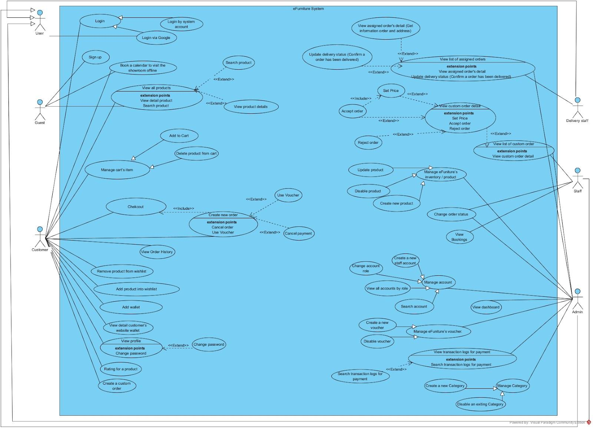

#### b. Descriptions

| **ID** | **Use Case** | **Actors** | **Use Case Description** |
| --- | --- | --- | --- |
| UC_AUTH_01 | Register | Guest | Allows new users to create an account on the platform to access additional features. |
| UC_AUTH_02 | Login | Guest, Customer, Supplier | Enables users to log into the system for personalized access and account management. |
| UC_AUTH_03 | Logout | Customer, Supplier | Allows users to log out of the system to secure their accounts. |
| UC_AUTH_04 | Refresh Token | Customer, Supplier | Provides a new token for users to continue their session without re-logging in. |
| UC_ORD_01 | Create Order | Customer | Allows customers to create new orders for products they wish to buy or rent. |
| UC_ORD_02 | Update Order Status | Admin, Supplier | Admin or supplier can update the status of orders (e.g., delivered). |
| UC_ORD_03 | View Order Details | Customer, Admin | Customers and admins can view the details of created orders. |
| UC_PROD_01 | Create Product | Supplier | Enables suppliers to create new products on the system with detailed information. |
| UC_PROD_02 | Update Product | Supplier | Allows suppliers to update existing product details such as price, description, or images. |
| UC_PROD_03 | View Product List | Customer, Supplier, Admin | Displays the list of products available to customers and suppliers. |
| UC_USER_01 | Update Profile | Customer, Supplier | Users can update their personal information in their accounts. |
| UC_USER_02 | Upgrade to Supplier | Customer | Customers can request to upgrade their account to supplier status. |
| UC_USER_03 | Downgrade to User | Supplier | Suppliers can downgrade their account back to user if there are no active orders. |
| UC_USER_04 | Manage Users | Admin | Admins can update or delete users from the system. |
| UC_USER_05 | View User Profile | Customer, Supplier, Admin | Users can view their own or other users' profile information. |
| UC_USER_06 | Search User | Admin | Admins can search for users based on specific criteria (e.g., name, email). |
| UC_PROD_04 | Remove Product | Supplier | Suppliers can remove products from the system. |
| UC_ORD_04 | Cancel Order | Customer | Customers can cancel their orders before processing. |
| UC_ORD_05 | View Order History | Customer | Customers can view their past orders. |

### 

## 2. Overall Functionalities

### 2.1 Screens Flow

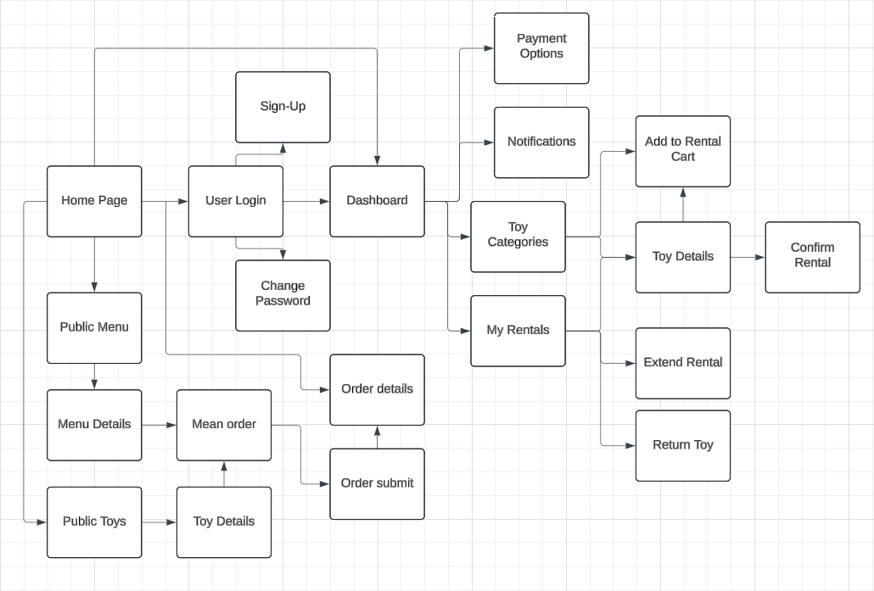

### 2.2 Screen Descriptions

| **#** | **Feature** | **Screen** | **Description** |
| --- | --- | --- | --- |
| 1 | Toy Selection and Submission | User Renting, User Offering | Users can browse available toys for rent or sale. Users offering toys can submit their toys along with pricing. |
| 2 | Rental/Sales Request Submission | User Renting, User Offering | Users renting toys can submit rental requests with pricing for 1 day, 1 week, and 2 weeks. Users offering toys can submit rental/sales requests. |
| 3 | Chat Functionality | User Renting, User Offering, Toy Supplier | Users and toy suppliers can communicate directly through a chat feature to discuss rentals or sales. |
| 4 | Request Management | Staff | System staff manage and verify requests for toy rentals and sales, ensuring correct pricing and validity of requests. |
| 5 | Tracking and Delivery Management | User Renting, Toy Supplier, Staff | Notifications and updates for the shipping and delivery of rented or purchased toys after payment confirmation. |
| 6 | Feedback and Rewards | User Renting | Users can provide feedback on the rental experience and earn reward points for returning toys in good condition, redeemable for discounts. |
| 7 | Inventory Management | Toy Supplier, User Offering | Toy suppliers and users offering toys can manage their inventory, including availability for sale and rental. |
| 8 | Support and Assistance | User Renting, User Offering, Staff | System staff provide support to users, assisting with rental/sales requests, resolving issues, and offering help with the platform. |
| 9 | System Maintenance and Security | IT Administrators | IT administrators monitor system security and perform maintenance to ensure the platform runs smoothly and securely. |
|  |  |  |  |
|  |  |  |  |
|  |  |  |  |

### 2.3 Screen Authorization

| **Screen** | **Customer** | **Toy Supplier** | **Staff** | **Guest** |
| --- | --- | --- | --- | --- |
| User Renting | X |  | X |  |
| Browse Toys | X | X | X | X |
| Submit Rental Reque | X |  |  |  |
| Chat with Suppliers | X |  |  |  |
| View Rental Status | X |  |  |  |
| User Offering | X | X | X |  |
| Submit Toy for Sale |  | X |  |  |
| Manage Listings |  | X |  |  |
| Track Earnings |  | X |  |  |
| Manage Inventory |  | X | X |  |
| Communicate with Users |  | X | X |  |
| Staff |  |  | X |  |
| Request Management |  |  | X |  |
| Manage User Support |  |  | X |  |
| Track Delivery |  | X | X |  |

| **#** | **Feature** | **System Function** | **Description** |
| --- | --- | --- | --- |
| 1 | <<Feature Name>> | <<Function Name1>> | <<Function Name1 Description>> |
| 2 | … |  |  |

## 3. System High Level Design

### 3.1 Database Design

#### a. Database Schema

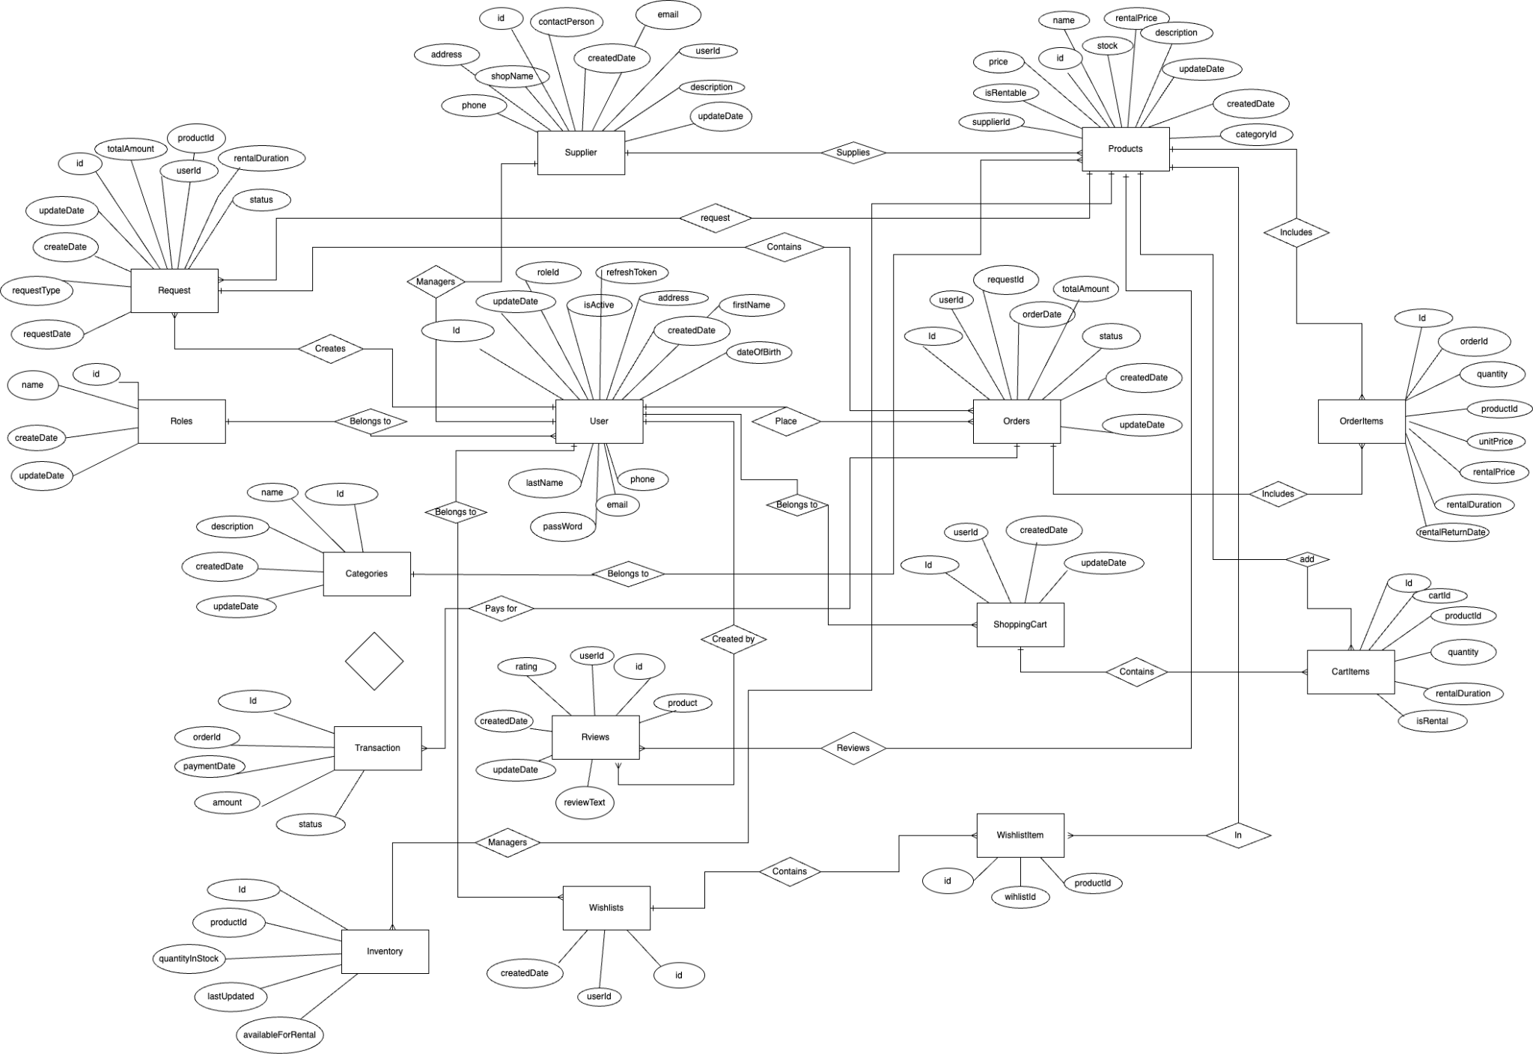

#### b. Table Descriptions

| **No** | **Table** | **Description** |
| --- | --- | --- |
| *01* | *Users* | *Stores user information including their personal details and credentials.*  *- Primary keys: id*  *- Foreign keys: roleId (refers to Roles.id)* |
| *02* | *Roles* | *Defines user roles within the system such as admin, supplier, etc.*  *- Primary keys: id*  *- Foreign keys: None* |
| *03* | *Suppliers* | *Holds information about suppliers, who provide products for sale or rental.*  *- Primary keys: id*  *- Foreign keys: userId (refers to Users.id)* |
| *04* | *Products* | *Stores product information, including sale price, rental price, and stock availability.*  *- Primary keys: id*  *- Foreign keys: supplierId (refers to Suppliers.id), categoryId (refers to Categories.id)* |
| *05* | *Cayegories* | *Contains product categories for organizing and grouping products. - Primary keys: id*  *- Foreign keys: None* |
| *07* | *Orders* | *Stores orders made by users, linking them to requests and tracking the order status.*  *- Primary keys: id*  *- Foreign keys: userId (refers to Users.id), requestId (refers to Requests.id)* |
| *08* | *OrderItems* | *Contains details of the products included in an order, such as quantity, unit price, and total price. Handles both sale and rental scenarios.*  *- Primary keys: id*  *- Foreign keys: orderId (refers to Orders.id), productId (refers to Products.id)* |
| *09* | *Transactions* | *Records payments associated with orders, including payment date, amount, and status.*  *- Primary keys: id*  *- Foreign keys: orderId (refers to Orders.id)* |
| *10* | *Reviews* | *Stores user reviews for products, including ratings and feedback.*  *- Primary keys: id*  *- Foreign keys: productId (refers to Products.id), userId (refers to Users.id)* |
| *11* | *ShoppingCart* | *Tracks the shopping cart for users, which holds items they intend to purchase or rent.*  *- Primary keys: id*  *- Foreign keys: userId (refers to Users.id)* |
| *12* | *CartItems* | *Stores items added to the user's shopping cart, with details such as quantity and rental duration.*  *- Primary keys: id*  *- Foreign keys: cartId (refers to ShoppingCart.id), productId (refers to Products.id)* |
| *13* | *Inventory* | *Tracks product inventory, including the total stock and rental availability.*  *- Primary keys: id*  *- Foreign keys: productId (refers to Products.id)* |
| *14* | *Wishlists* | *Stores wishlists created by users to track products they are interested in.*  *- Primary keys: id*  *- Foreign keys: userId (refers to Users.id)* |
| *15* | *WishlistItems* | *Contains items added to user wishlists, linking products to the wishlist.*  *- Primary keys: id*  *- Foreign keys: wishlistId (refers to Wishlists.id), productId (refers to Products.id)* |

### 3.2 Code Packages

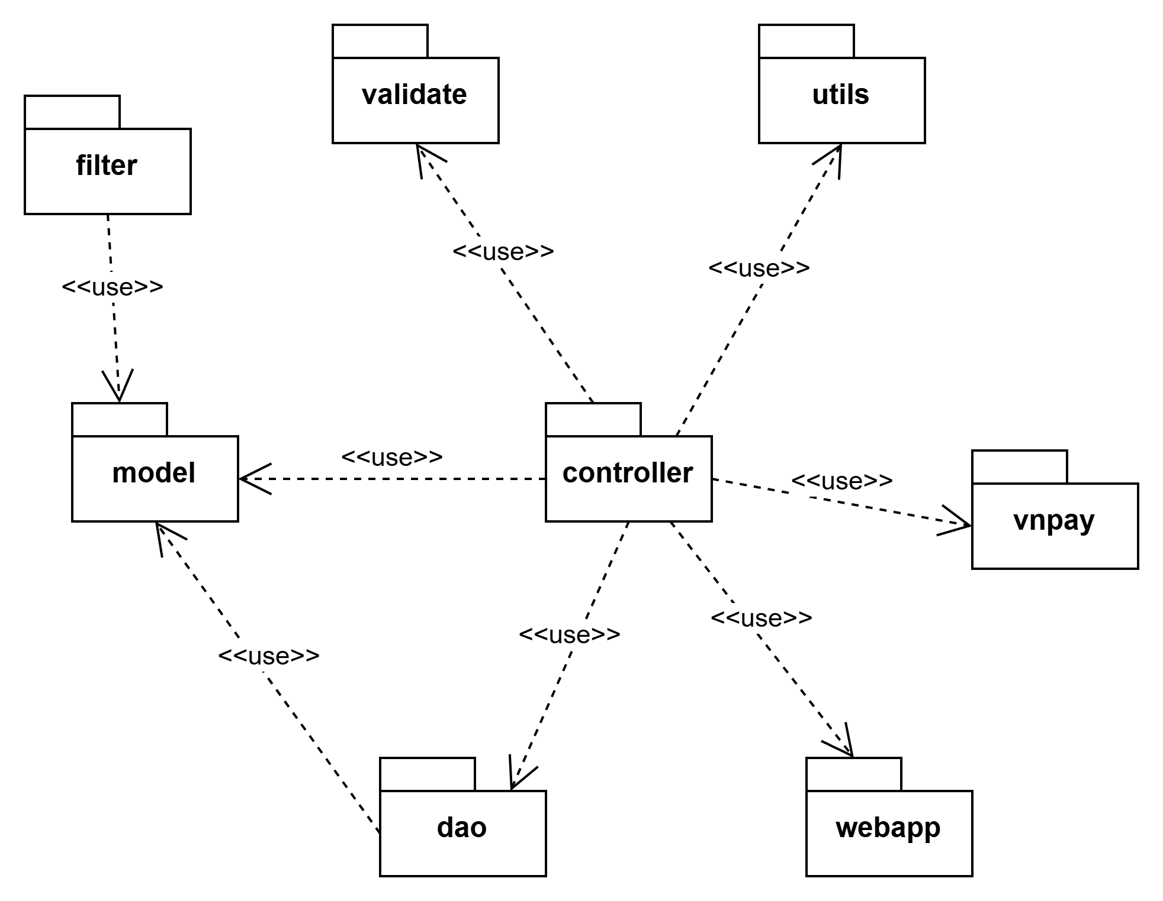

***Package descriptions***

| **No** | **Package** | **Description** |
| --- | --- | --- |
| *01* | controller | A controller package, in the context of software development, refers to a component or module within an application or system that plays a crucial role in managing and directing the flow of data and interactions between various parts of the software. |
| *02* | util | A util package is a collection of reusable, general-purpose functions, classes, or modules that provide common functionalities and tools that can be used across different parts of an application or system. These utilities are typically designed to simplify coding tasks, improve code organisation, and promote code reusability. |
| *03* | dao | A DAO package is responsible for abstracting and encapsulating the methods and operations necessary to access, manipulate, and interact with data. |
| *04* | model | A model package typically refers to a component or module within an application that is responsible for defining and encapsulating the data structures, business logic, and rules that represent the core functionality and behaviour of the application. |
| *05* | webapp | A "web package" is a broad term that can refer to various components, modules, or directories within a web application or web-based project. The contents and purpose of a web package can vary depending on the specific framework, technology stack, or project structure being used. |
| *06* | vnpay | Package for configuration params for processing payment via vn pay api. |
| *07* | filter | Package contain the filter for user authentication |
| *08* | validate | Package contain the validation method for ensuring input data match the right format of system |

# II. Requirement Specifications

## 1. Guest

### 1.1 Sign up

#### a. Functionalities

**Functional Description Template**

| UC ID and Name: | UC_AUTH_01 | | |
| --- | --- | --- | --- |
| Created By: | Lê Nguyễn Thanh Phong | Date Created: | Oct 29, 2024 |
| Primary Actor: | Guest | Secondary Actors: | NA |
| Trigger: | A guest clicks the user icon on the header and clicks sign up to create a new account. | | |
| Description: | The “sign up” use case represents the process performed by the guest to create a new account as a customer of EduToy. The guest enters the required information to sign up for an account . The guest then presses the “sign up” button, or presses “Enter” on their keyboard to finalize the sign up action. | | |
| Preconditions: | PRE-1: The guest has not already registered.  PRE-2: The guest has a stable internet connection. | | |
| Postconditions: | POST-1: The guest’s information is saved into eFurniture’s database if the sign up process is successful.  POST-2: The application will send a successful sign up message.  POST-3: The application is redirected into the login page. | | |
| Normal Flow: | 1. The guest clicks on the User icon then clicks Sign up. 2. The system will redirect the guest into the registration page. 3. The guest enters all the required information into the registration form. 4. The guest confirms form submission by clicking the “Sign up” button, or by pressing “Enter” on their keyboard. 5. The system will send a confirmation message indicating the signup process is successful. | | |
| Alternative Flows: | N/A | | |
| Exceptions: | 1-EF: At any time, the app cannot communicate with the server/core system (due to network malfunction/technical issues), the system displays an error message.  2-EF: The data in the registration form is in the wrong format. | | |
| Priority: | High | | |
| Frequency of Use: | Always | | |
| Business Rules: |  | | |
| Other Information: | N/A | | |
| Assumptions: | A-1: User has a stable internet connection. | | |

### 1.2 Log in

| UC ID and Name: | UC_AUTH_02 | | |
| --- | --- | --- | --- |
| Created By: | Lê Nguyễn Thanh Phong | Date Created: | Oct 29, 2024 |
| Primary Actor: | Guest | Secondary Actors: | NA |
| Trigger: | A guest clicks the user icon on the header and clicks log in | | |
| Description: | The guest want to sign into the website, | | |
| Preconditions: | PRE-1: The guest has already registered an account.  PRE-2: The guest has a stable internet connection. | | |
| Postconditions: | POST-1: The guest will be logged in  POST-2: The system is redirected into the login page. | | |
| Normal Flow: | 1. The guest clicks the user icon. 2. The guest chooses the login option. 3. The guest fills in the log in form. 4. The guest clicks sign in. 5. The guest logged in. 6. System direct user to homepage. | | |
| Alternative Flows: | N/A | | |
| Exceptions: | 1-EF: At any time, the app cannot communicate with the server/core system (due to network malfunction/technical issues), the system displays an error message.  2-EF: The data in the registration form is in the wrong format. | | |
| Priority: | Higj | | |
| Frequency of Use: | Always | | |
| Business Rules: | BR-3, BR-6, BR-5, BR-7 | | |
| Other Information: | N/A | | |
| Assumptions: | A-1: User has a stable internet connection. | | |

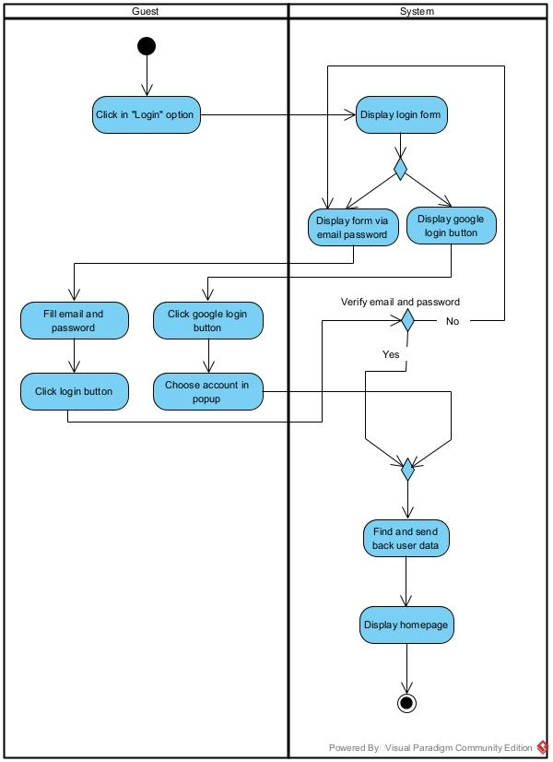

#### b. Business Rules

Provide the business rules those are applied only to the use case

| **ID** | **Business Rule** | **Business Rule Description** |
| --- | --- | --- |
| FR1 | Password Encoding | User’s password must be encoded with MD5 hashing |

## 2. Suppliers

### 2.1 UC-1_Add Toy to Inventory

| UC ID and Name: | UC_PROD_01 | | |
| --- | --- | --- | --- |
| Created By: | Lê Nguyễn Thanh Phong | Date Created: | Oct 29, 2024 |
| Primary Actor: | Suppliers | Secondary Actors: |  |
| Trigger: | Clicks the "Add Toy" button in the Inventory Management system. | | |
| Description: | As an Suppliers, I want to be able to add new toys to the inventory so that they can be tracked and managed within the system. | | |
| Preconditions: | Suppliers is logged into the system.  Suppliers has the necessary permissions to add items to the inventory. | | |
| Postconditions: | Toy is successfully added to the inventory.  The system updates the inventory list with the new toy. | | |
| Normal Flow: | 1. Suppliers accesses the Add Toy screen from the Inventory Management system.  2. Suppliers enters the toy details (e.g., name, category, price, stock quantity).  3. Suppliers clicks the "Save" button.  4. System validates the entered details (e.g., checks for required fields, ensures no duplicate entries).  5. System adds the toy to the inventory database.  6. System updates the inventory list to include the new toy.  7. System displays a confirmation message indicating that the toy has been successfully added. | | |
| Alternative Flows: | **1.1 Invalid Toy Details**  1. Suppliers enters invalid or incomplete toy details.  2. System displays an error message indicating which fields need correction.  3. Suppliers corrects the details and clicks "Save" again.  4. Return to step 4 of the normal flow. | | |
| Exceptions: | **1.0.E1 System can’t add the toy**  The Error Message screen is shown to the Inventory Manager.  Suppliers reviews the error and corrects any issues.  If necessary, the Suppliers cancels the addition => UC stops, return to the Inventory Management screen.  If the issue is related to system performance or database issues, the Suppliers contacts technical support. | | |
| Priority: | High (Medium, Low), Must Have (Should Have, Could Have),.. | | |
| Frequency of Use: |  | | |
| Business Rules: | **FR1:** The system must validate that all required fields for adding a toy are filled out.  **FR2:** The system must ensure that duplicate toys are not added to the inventory.  **FR3:** The system must log each addition of a toy to the inventory in the Activity Log. | | |
| Other Information: | The Add Toy screen should be accessible only to users with appropriate permissions. | | |
| Assumptions: | Inventory Manager has a user account with the necessary permissions.  The system has a reliable connection to the inventory database. | | |

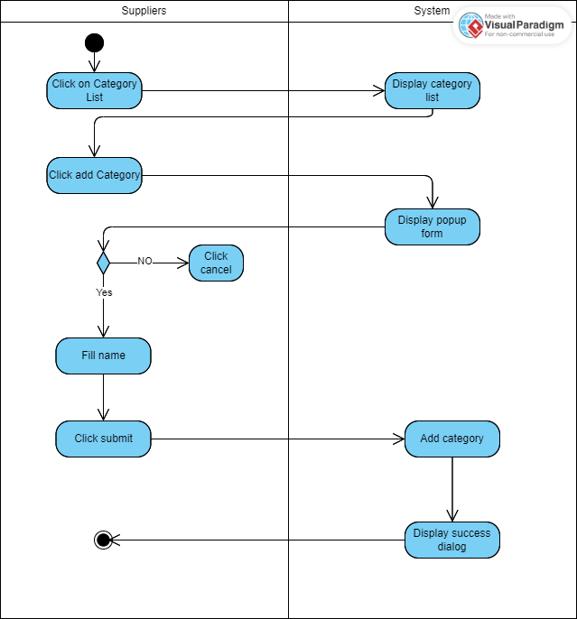

#### b. Business Rules

| **ID** | **Business Rule** | **Business Rule Description** |
| --- | --- | --- |
| FR1 | Required Fields Validation | The system must validate that all required fields for adding a toy to the inventory are filled out. Required fields include toy name, category, price, and stock quantity |
| FR2 | Duplicate Toy Prevention | The system must ensure that duplicate toys are not added to the inventory. Before adding a new toy, the system should check for existing entries with the same name and category. |
| FR3 | Activity Log Recording | The system must log each addition of a toy to the inventory in the Activity Log. This log should include details such as the toy's name, the date and time of the addition, and the user who performed the action. |

### 2.1 UC-2_Update Toy Information

| UC ID and Name: | UC_PROD_02 | | |
| --- | --- | --- | --- |
| Created By: | Lê Nguyễn Thanh Phong | Date Created: | Oct 29, 2024 |
| Primary Actor: | Suppliers | Secondary Actors: |  |
| Trigger: | Supplier logs into the system and selects the "Update Toy Information" option to modify details about toys they supply. | | |
| Description: | As a Supplier, I want to be able to update the information of toys I supply so that the inventory system reflects the most accurate and current details about the toys I provide. | | |
| Preconditions: | The supplier has an active account and is logged into the system with the necessary permissions to update toy information.  The toy to be updated is one that the supplier has provided or is responsible for. | | |
| Postconditions: | Toy is successfully added to the inventory.  The system updates the inventory list with the new toy. | | |
| Normal Flow: | **2.1 Update Toy**  1.Supplier logs into the system  2. Supplier navigates to the "Update Toy Information" section.  3. Supplier searches for the toy they want to update using search criteria (e.g., toy name, category).  4. The system displays the details of the selected toy.  5. Supplier selects the "Update" option to edit the toy information.  6. Supplier updates the required fields (e.g., toy name, category, price, stock quantity) and any other relevant details.  7. Supplier clicks the "Save" button to submit the changes.  8. The system validates the updated details  9. The system updates the toy information in the inventory.  10. The system displays a confirmation message to the Supplier indicating that the update was successful. | | |
| Alternative Flows: | **UC-2.2: Validation Error**  1.Supplier clicks the "Save" button.  2.The system detects validation errors (e.g., missing required fields, invalid data).  3.The system displays error messages indicating the issues.  4.Supplier corrects the errors and repeats steps 6-8 of the Normal Flow.  **UC-2.3: Cancel Update**  1.Supplier decides to cancel the update.  2.Supplier clicks the "Cancel" button.  3.The system discards any changes and returns to the "Update Toy Information" screen. | | |
| Exceptions: | **UC-2.E1: System Validation Failure**   1. The system detects an issue with the updated details (e.g., data inconsistency, constraints violation). 2. The system displays an error message and prevents the update from being saved. 3. Supplier corrects the issue as directed by the error message. | | |
| Priority: | Medium | | |
| Frequency of Use: |  | | |
| Business Rules: | **FR1:** The system must validate that all required fields for adding a toy are filled out.  **FR2:** The system must ensure that duplicate toys are not added to the inventory.  **FR3:** The system must log each addition of a toy to the inventory in the Activity Log. | | |
| Other Information: | Suppliers should be provided with clear instructions on the format and requirements for updating toy information. | | |
| Assumptions: | The system interface allows suppliers to easily search for and update toy details.  Suppliers have the necessary permissions to make updates to toy information. | | |

#### b. Business Rules

| **ID** | **Business Rule** | **Business Rule Description** |
| --- | --- | --- |
| FR1 | Required Fields Validation | The system must validate that all required fields for adding a toy to the inventory are filled out. Required fields include toy name, category, price, and stock quantity |
| FR2 | Duplicate Toy Prevention | The system must ensure that duplicate toys are not added to the inventory. Before adding a new toy, the system should check for existing entries with the same name and category. |
| FR3 | Activity Log Recording | The system must log each addition of a toy to the inventory in the Activity Log. This log should include details such as the toy's name, the date and time of the addition, and the user who performed the action. |

### 2.1 UC-3_ Fulfill Rental Request

| UC ID and Name: | UC-3_Fulfill Rental Request | | |
| --- | --- | --- | --- |
| Created By: | Thinhdt | Date Created: | 15/9/2024 |
| Primary Actor: | Suppliers | Secondary Actors: | Customer |
| Trigger: | Supplier receives a notification of a rental request involving their items and initiates the process to fulfill it. | | |
| Description: | As a Supplier, I want to be able to fulfill rental requests for the items I provide so that the rental process is completed smoothly, and customers receive their requested items on time. | | |
| Preconditions: | The rental request has been received and includes items supplied by the Supplier.  The Supplier has access to the rental management system or relevant communication channels.  The requested items are in stock and available for rental. | | |
| Postconditions: | The rental request is fulfilled, and the items are prepared for the customer.  The Supplier updates the status of the rental in the system or notifies the Cutomer.  The system or Supplier tracks the rental transaction and updates inventory accordingly. | | |
| Normal Flow: | **2.1 Fullfill Rental Request**  1. Supplier receives a rental request notification involving their items.  2. Supplier reviews the rental request details, including the item(s) requested and customer information.  3. Supplier verifies the availability of the requested items in their inventory.  4. Supplier updates the inventory to reflect that the item(s) are reserved for the rental request.  5. Supplier prepares the item(s) for rental (e.g., packaging, labeling).  6. Supplier notifies the Rental Agent about the readiness of the item(s) for pickup or delivery.  7. Supplier confirms the rental details with the Customer, including the rental period and any other relevant terms.  8. Supplier updates the rental status in the system or provides confirmation to the Customer.  9. System or Supplier logs the rental transaction in the Activity Log or relevant tracking system.  10. Supplier ensures the item(s) are delivered to the customer or scheduled for pickup as per the agreement. | | |
| Alternative Flows: | **UC-3.1: Item Not Available**   1. Supplier checks inventory and finds that the item(s) are not available. 2. Supplier informs the Rental Agent and suggests alternative items or reschedules the rental. 3. Supplier updates the system or communicates the new rental status.   **UC-3.2: Delivery Issues**   1. Supplier encounters issues with delivering the item(s) (e.g., logistical problems). 2. Supplier communicates with the Rental Agent and customer to resolve delivery issues. 3. Supplier updates the delivery schedule or provides alternative solutions. | | |
| Exceptions: | **UC-3.E1: System Failure**   1. The Supplier experiences an issue with the system while processing the rental request. 2. Supplier receives an error message and attempts to resolve the issue or contacts technical support. 3. If the issue persists, Supplier manually tracks the rental request and informs Staff. | | |
| Priority: | Medium | | |
| Frequency of Use: |  | | |
| Business Rules: | **BR-01:** The Supplier must verify that the requested items are available before confirming the rental request.  **BR-02:** The Supplier must update the inventory to reflect the reservation of items.  **BR-03:** The Supplier must communicate clearly with the Rental Agent and ensure accurate tracking of rental transactions.  **BR-04:** The Supplier must log the rental transaction in the Activity Log or relevant tracking system. | | |
| Other Information: | Ensure that the system interface provides clear instructions and access to manage rental requests effectively. | | |
| Assumptions: | he Supplier has the necessary access and permissions to manage rental requests and inventory.  The rental management system is operational and up-to-date with accurate inventory information. | | |

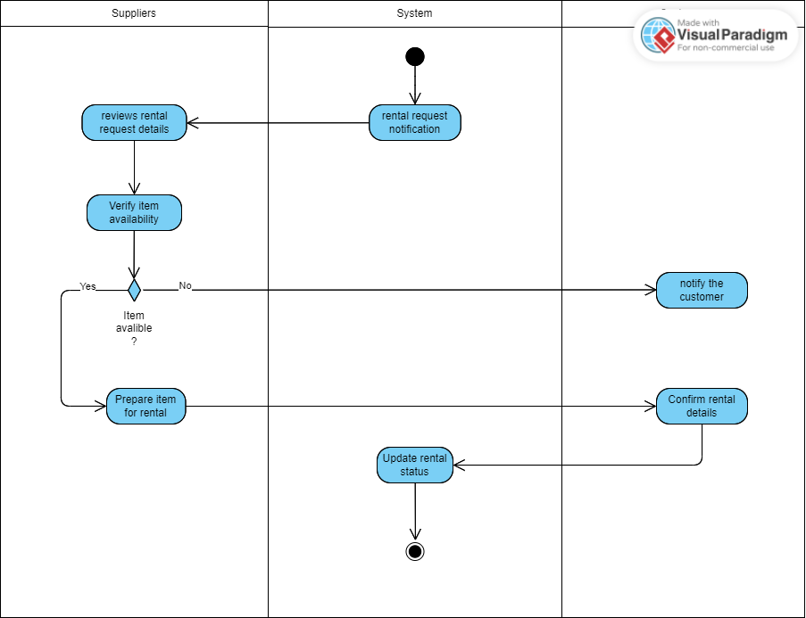

#### b. Business Rules

| **ID** | **Business Rule** | **Business Rule Description** |
| --- | --- | --- |
| **BR-01** | Item Availability Verification | The Supplier must verify that the requested items are available before confirming the rental request. |
| **BR-02** | Inventory Update | The Supplier must update the inventory to reflect the reservation of items. |
| **BR-03** | Delivery Schedule | The Supplier must communicate clearly with the Rental Agent and ensure accurate tracking of rental transactions. |
| **BR-04** | Transaction Logging | The Supplier must log the rental transaction in the Activity Log or relevant tracking system. |

### 2.1 UC-4_ Update Rental Status

| UC ID and Name: | UC-4_Update Rental Status | | |
| --- | --- | --- | --- |
| Created By: | Thinhdt | Date Created: | 15/9/2024 |
| Primary Actor: | Suppliers | Secondary Actors: | Customer |
| Trigger: | The Supplier needs to update the status of a rental order | | |
| Description: | As a Supplier, I want to be able to update the rental status in the system at different stages of the rental process to keep the customer informed and ensure proper tracking of rented items. | | |
| Preconditions: | The Supplier has access to the rental management system.  The rental order has been created, and the Supplier is responsible for managing it | | |
| Postconditions: | The rental status is updated in the system.  The Customer and Rental Agent are notified of the updated status.  The status change is logged in the system for tracking purposes. | | |
| Normal Flow: | 1.Supplier accesses the rental management system and selects the relevant rental order.  2.Supplier reviews the current status of the rental order.  3.Supplier updates the status based on the current stage  4.Supplier confirms the status update, ensuring it accurately reflects the current state of the rental order.  5.System logs the status change and updates the Activity Log for tracking and auditing purposes.  6.System sends notifications to the Customer regarding the updated rental status.  7.Supplier follows up if needed, ensuring that the item is delivered or returned as per the agreement. | | |
| Alternative Flows: | **UC-4.2:Incorrect Status Update**   1. Supplier realizes that the status update was incorrect. 2. Supplier corrects the rental status and updates the system. 3. System sends updated notifications to the Customer and Rental Agent. 4. The correction is logged in the system for auditing purposes.   **UC-4.3: Escalation Required for Complex Issues**   1. Supplier determines that a rental issue needs escalation ( item is delayed or unavailable). 2. Supplier informs the Customer about the escalation and the expected resolution time. 3. System tracks the escalation, and the updated status is reflected once resolved. | | |
| Exceptions: | **UC-4.E1: System Outage**   1. The rental management system is unavailable or experiencing issues. 2. Supplier informs the IT department to resolve the issue. 3. Rental status is updated manually or later when the system is back online.   **UC-4.E2: Incorrect Information**   1. Supplier realizes that incorrect information was given regarding the rental status. 2. Supplier corrects the information and sends a follow-up update to the Customer 3. Both the incorrect and corrected updates are logged in the system. | | |
| Priority: | Medium | | |
| Frequency of Use: |  | | |
| Business Rules: | **BR-05**: The Supplier must ensure that all rental status updates are accurate and reflect the current state of the rental process.  **BR-06**: All status updates must be logged in the system for tracking and auditing purposes.  **BR-07**: If there is an issue or delay in updating the rental status, the Supplier must notify the Customer  **BR-08**: The Supplier must ensure that the Customer receive timely notifications about the status changes. | | |
| Other Information: | Ensure the rental management system is capable of handling multiple status updates efficiently and maintaining accurate records for each transaction stage. | | |
| Assumptions: | N/A | | |

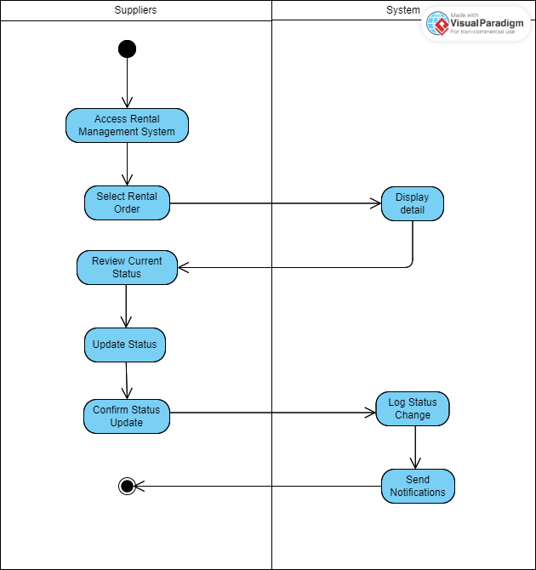

#### b. Business Rules

| **ID** | **Business Rule** | **Business Rule Description** |
| --- | --- | --- |
| **BR-05** | Accurate Response Requirement | The Supplier must ensure that all responses are accurate and based on up-to-date information about products, services, or orders. |
| **BR-06** | Query Logging | All queries and responses must be logged for tracking and auditing purposes. |
| **BR-07** | Escalation Process | If a query requires escalation, the Supplier must follow the escalation process and notify the buyer of the status and expected resolution time. |
| **BR-08** | Follow-Up Communication | The Supplier must ensure that the Customer receive timely notifications about the status changes. |

### 2.1 UC-5_ Prepare Toys for Delivery

| UC ID and Name: | UC-5_ Prepare Toys for Delivery | | |
| --- | --- | --- | --- |
| Created By: | Thinhdt | Date Created: | 15/9/2024 |
| Primary Actor: | Suppliers | Secondary Actors: | System |
| Trigger: | A rental or purchase order is confirmed and ready for delivery. | | |
| Description: | The Supplier packages and prepares toys for delivery, ensuring they are labeled and scheduled for pickup or shipping. | | |
| Preconditions: | A confirmed order exists.  Toys are available in inventory.  Delivery details are provided. | | |
| Postconditions: | Toys are packaged and ready for delivery.  The system is updated, and the Customer is notified. | | |
| Normal Flow: | **2.1Prepare Toys**  1.Supplier receives the order confirmation.  2.Supplier retrieves the toys from inventory.  3.Supplier packages and labels the toys.  4.Supplier updates the system and schedules delivery.  5.Customer is notified that the toys are ready for shipping. | | |
| Alternative Flows: | **UC-5.1: Insufficient Inventory**   1. Supplier discovers insufficient inventory to fulfill the order. 2. Supplier contacts the Customer to discuss alternatives (e.g., substitute items or delay). 3. If an alternative is agreed upon, the process continues; otherwise, the order may be canceled.   **UC-5.2: Packaging Issues**   1. Supplier encounters issues with packaging materials. 2. Supplier obtains necessary materials and resumes preparation. 3. System logs any delays in preparation. | | |
| Exceptions: | **UC-5.E1: System Outage**  1 The system is down, preventing updates or notifications.  2 Supplier manually tracks preparation and updates the system later.  **UC-5.E2: Incorrect Delivery Information**  1 Supplier realizes the delivery details are incorrect.  2 Supplier contacts the Customer for clarification and corrects the information before proceeding. | | |
| Priority: | Medium | | |
| Frequency of Use: |  | | |
| Business Rules: | **BR-11**: All orders must be prepared according to company packaging standards.  **BR-12**: Delivery updates must be logged for tracking purposes.  **BR-13**: Suppliers must communicate any issues with preparation to the Customer promptly. | | |
| Other Information: | Ensure packaging materials are sufficient and that the delivery schedule aligns with customer expectations. | | |
| Assumptions: | N/A | | |

#### b. Business Rules

| **ID** | **Business Rule** | **Business Rule Description** |
| --- | --- | --- |
| **BR-11** | Packaging Standards | All toys must be packaged according to company standards to ensure safe transport and presentation. |
| **BR-12** | Delivery Update Logging | All delivery updates, including status changes and notifications, must be logged in the system for tracking. |
| **BR-13** | Communication of Issues | Suppliers must promptly communicate any issues encountered during preparation or shipping to the Customer. |
|  |  |  |

## 3.2 Customer

### 3.2.1 Rent Toy

### 

#### a. Functionalities

| **Use Case Specification** | | | |
| --- | --- | --- | --- |
| **Use Case ID and Name:** | UC_CU_01 – Rent Toy | | |
| **Created By:** | Lê Nguyễn Thanh Phong | **Date Created:** | Sep 19, 2024 |
| **Primary Actor:** | Customer | **Secondary Actors:** | N/A |
| **Trigger:** | A customer selects a toy to rent and specifies the rental period. | | |
| **Description:** | Customers can request to rent educational toys, specifying the rental period (1 day, 1 week, or 2 weeks) and corresponding rental prices. | | |
| **Pre-conditions:** | PRE-1: The customer is logged into their account. PRE-2: The selected toy is available for rent. | | |
| **Post-conditions:** | POST-1: The rental order is successfully placed. POST-2: A confirmation message is sent to the customer. | | |
| **Normal Flow:** | 1. The customer selects a toy to rent. 2. The customer chooses the rental period (1 day, 1 week, or 2 weeks). 3. The customer proceeds to checkout. 4. The system confirms the rental order and provides rental details. | | |
| **Alternative Flows:** | N/A | | |
| **Exceptions:** | 1-EF: If the toy is not available, an error message is displayed. | | |
| **Priority:** | High | | |
| **Frequency of Use:** | Frequent | | |
| **Business Rules:** | BR-01, BR-02, BR-05, BR-10, BR-11 | | |
| **Other Information:** | N/A | | |
| **Assumptions:** | A-1: The customer has a stable internet connection. | | |

#### b. Business Rules

| **ID** | **Business Rule** | **Business Rule Description** |
| --- | --- | --- |
| BR-01 | Item Availability Verification | The Supplier must verify that the requested items are available before confirming the rental request. |
| BR-02 | Inventory Update | The Supplier must update the inventory to reflect the reservation of items. |
| BR-05 | Accurate Response Requirement | The Supplier must ensure that all responses are accurate and based on up-to-date information about products, services, or orders. |
| BR-10 | Accurate Total Calculation | The system must ensure that the total rental or purchase amount is calculated correctly based on the selected items and their prices. |
| BR-11 | Confirmation Email | The customer must receive a confirmation email with the rental or purchase details after the transaction is completed. |

### 3.2.2 Buy Toy

#### a. Functionalities

| **Use Case Specification** | | | |
| --- | --- | --- | --- |
| **Use Case ID and Name:** | UC_CU_02 – Buy Toy | | |
| **Created By:** | Lê Nguyễn Thanh Phong | **Date Created:** | Sep 19, 2024 |
| **Primary Actor:** | Customer | **Secondary Actors:** | N/A |
| **Trigger:** | A customer selects a toy to buy. | | |
| **Description:** | Allows customers to purchase toys directly from the platform using various payment methods. | | |
| **Pre-conditions:** | PRE-1: The customer is logged into their account. PRE-2: The selected toy is available for purchase. | | |
| **Post-conditions:** | POST-1: The purchase is successfully completed. POST-2: A confirmation message is sent to the customer. | | |
| **Normal Flow:** | 1. The customer selects a toy to purchase. 2. The customer proceeds to checkout. 3. The system processes the payment. 4. The system confirms the order and provides purchase details. | | |
| **Alternative Flows:** | N/A | | |
| **Exceptions:** | 1-EF: If the payment fails, the customer is prompted to retry or choose another method. | | |
| **Priority:** | High | | |
| **Frequency of Use:** | Frequent | | |
| **Business Rules:** | BR-02, BR-05, BR-10, BR-11, BR-12, BR-13 | | |
| **Other Information:** | N/A | | |
| **Assumptions:** | A-1: The customer has a stable internet connection. | | |

#### b. Business Rules

| **ID** | **Business Rule** | **Business Rule Description** |
| --- | --- | --- |
| BR-02 | Inventory Update | The Supplier must update the inventory to reflect the reservation of items. |
| BR-05 | Accurate Response Requirement | The Supplier must ensure that all responses are accurate and based on up-to-date information about products, services, or orders. |
| BR-10 | Accurate Total Calculation | The system must ensure that the total rental or purchase amount is calculated correctly based on the selected items and their prices. |
| BR-11 | Confirmation Email | The customer must receive a confirmation email with the rental or purchase details after the transaction is completed. |
| BR-12 | Stock Level Check | The system must check the stock level of items before allowing the customer to add them to the cart. |
| BR-13 | Order Tracking Updates | The system must provide order tracking updates once the rental or purchase request is confirmed. |

### 3.2.2 Manage Cart

#### a. Functionalities

| **Use Case Specification** | | | |
| --- | --- | --- | --- |
| **Use Case ID and Name:** | UC_CU_03 – Manage Cart | | |
| **Created By:** | Lê Nguyễn Thanh Phong | **Date Created:** | Sep 19, 2024 |
| **Primary Actor:** | Customer | **Secondary Actors:** | N/A |
| **Trigger:** | A customer adds or removes a toy from their shopping cart. | | |
| **Description:** | Allows customers to add, remove, or manage the toys in their shopping cart before proceeding to checkout. | | |
| **Pre-conditions:** | PRE-1: The customer is logged into their account. PRE-2: The toy is available to be added to the cart. | | |
| **Post-conditions:** | POST-1: The toy is successfully added or removed from the cart. | | |
| **Normal Flow:** | 1. The customer adds a toy to the cart. 2. The customer removes or updates the quantity of toys in the cart. 3. The customer reviews the cart before checkout. | | |
| **Alternative Flows:** | N/A | | |
| **Exceptions:** | 1-EF: If the toy is no longer available, an error message is displayed. | | |
| **Priority:** | High | | |
| **Frequency of Use:** | Frequent | | |
| **Business Rules:** | BR-02, BR-10, BR-12 | | |
| **Other Information:** | N/A | | |
| **Assumptions:** | A-1: The customer has a stable internet connection. | | |

#### b. Business Rules

| **ID** | **Business Rule** | **Business Rule Description** |
| --- | --- | --- |
| BR-02 | Inventory Update | The Supplier must update the inventory to reflect the reservation of items. |
| BR-10 | Accurate Total Calculation | The system must ensure that the total rental or purchase amount is calculated correctly based on the selected items and their prices. |
| BR-12 | Stock Level Check | The system must check the stock level of items before allowing the customer to add them to the cart. |

### 3.2.4 Checkout

#### a. Functionalities

| **Use Case Specification** | | | |
| --- | --- | --- | --- |
| **Use Case ID and Name:** | UC_CU_04 – Checkout | | |
| **Created By:** | Lê Nguyễn Thanh Phong | **Date Created:** | Sep 19, 2024 |
| **Primary Actor:** | Customer | **Secondary Actors:** | N/A |
| **Trigger:** | A customer proceeds to checkout after managing their cart. | | |
| **Description:** | Customers can complete their orders by making payments for the selected rented or purchased toys. | | |
| **Pre-conditions:** | PRE-1: The customer has toys in their cart. PRE-2: The payment provider is available. | | |
| **Post-conditions:** | POST-1: The order is successfully processed. POST-2: A confirmation message is sent to the customer. | | |
| **Normal Flow:** | 1. The customer reviews the cart. 2. The customer selects a payment method. 3. The system processes the payment. 4. The system confirms the order and provides details. | | |
| **Alternative Flows:** | N/A | | |
| **Exceptions:** | 1-EF: If the payment fails, the system prompts the customer to retry. | | |
| **Priority:** | High | | |
| **Frequency of Use:** | Frequent | | |
| **Business Rules:** | BR-02, BR-10, BR-11, BR-12, BR-13 | | |
| **Other Information:** | N/A | | |
| **Assumptions:** | A-1: The customer has a stable internet connection. | | |

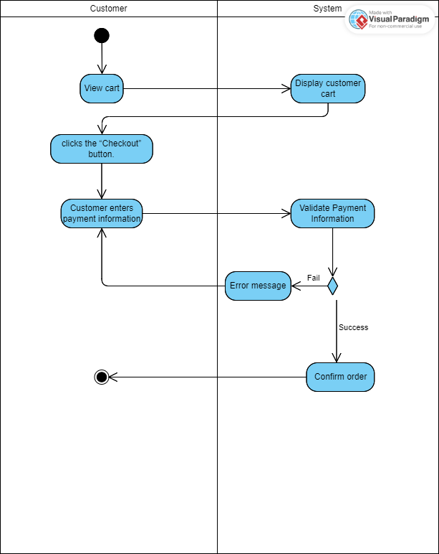

#### b. Business Rules

| **ID** | **Business Rule** | **Business Rule Description** |
| --- | --- | --- |
| BR-02 | Inventory Update | The Supplier must update the inventory to reflect the reservation of items. |
| BR-10 | Accurate Total Calculation | The system must ensure that the total rental or purchase amount is calculated correctly based on the selected items and their prices. |
| BR-11 | Confirmation Email | The customer must receive a confirmation email with the rental or purchase details after the transaction is completed. |
| BR-12 | Stock Level Check | The system must check the stock level of items before allowing the customer to add them to the cart. |
| BR-13 | Order Tracking Updates | The system must provide order tracking updates once the rental or purchase request is confirmed. |

### 3.2.5 View Order History

#### a. Functionalities

| **Use Case Specification** | | | |
| --- | --- | --- | --- |
| **Use Case ID and Name:** | UC_CU_05 – View Order History | | |
| **Created By:** | Lê Nguyễn Thanh Phong | **Date Created:** | Sep 19, 2024 |
| **Primary Actor:** | Customer | **Secondary Actors:** | N/A |
| **Trigger:** | A customer selects the 'Order History' option from their account page. | | |
| **Description:** | Allows customers to view the history of their previous orders, including both rented and purchased toys. | | |
| **Pre-conditions:** | PRE-1: The customer is logged into their account. | | |
| **Post-conditions:** | POST-1: The customer can view the details of their past orders. | | |
| **Normal Flow:** | 1. The customer navigates to their profile page. 2. The customer selects 'Order History'. 3. The system displays the details of previous orders, including status, dates, and amounts. | | |
| **Alternative Flows:** | N/A | | |
| **Exceptions:** | N/A | | |
| **Priority:** | Medium | | |
| **Frequency of Use:** | Occasional | | |
| **Business Rules:** | BR-09, BR-11, BR-13 | | |
| **Other Information:** | N/A | | |
| **Assumptions:** | A-1: The customer has a stable internet connection. | | |

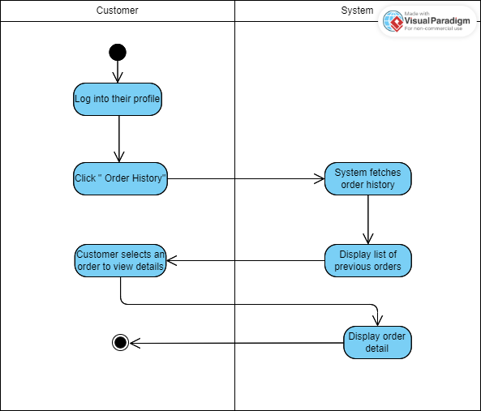

#### b. Business Rules

| **ID** | **Business Rule** | **Business Rule Description** |
| --- | --- | --- |
| BR-09 | View Own Order History | The system must ensure that customers can only view their own order history. |
| BR-11 | Confirmation Email | The customer must receive a confirmation email with the rental or purchase details after the transaction is completed. |
| BR-13 | Order Tracking Updates | The system must provide order tracking updates once the rental or purchase request is confirmed. |

### 3.2.6. Change Password for Customer

#### 

| **Use Case Specification** | | | |
| --- | --- | --- | --- |
| **Use Case ID and Name:** | UC_CU_06 – View Order History | | |
| **Created By:** | Bùi Văn Tuấn Lâm | **Date Created:** | Sep 24, 2024 |
| **Primary Actor:** | Customer | **Secondary Actors:** | N/A |
| **Trigger:** | A customer indicates that they want to change their account password. | | |
| **Description:** | This use case involves the process of a customer changing their account password. It ensures secure password updates to maintain account security. | | |
| **Pre-conditions:** | PRE-1: Customer must be logged into the system.  PRE-2: Customer must remember their current password to change it. | | |
| **Post-conditions:** | POST-1: The customer's password is successfully updated in the system.  POST-2: The customer is prompted to log in again using the new password (optional). | | |
| **Normal Flow:** | 1. Customer navigates to the account settings or profile section.  2. Customer selects the option to change the password.  3. System prompts the customer to enter their current password.  4. Customer enters the new password twice (for confirmation).  5. System validates the current password and checks that the new password meets security requirements.  6. System updates the password and confirms the change to the customer. | | |
| **Alternative Flows:** | 1-AF: Customer forgets current password, prompting the option to reset the password through a "Forgot Password" feature.  2-AF: Customer cancels the process before confirmation, and no changes are made. | | |
| **Exceptions:** | 1-EF: Customer enters incorrect current password.  6. Error Notification: The system informs the customer that the current password is incorrect.  7. System allows the customer to retry or cancel the operation. | | |
| **Priority:** | High | | |
| **Frequency of Use:** | Low to Medium | | |
| **Business Rules:** | Customer may be required to verify their identity through two-factor authentication (2FA) or other means. | | |
| **Other Information:** | N/A | | |
| **Assumptions:** | A-1: Customer remembers their current password.  A-2: System is available and functioning properly for password changes. | | |

### 3.2.7. Customer Rating

#### 

| **Use Case Specification** | | | |
| --- | --- | --- | --- |
| **Use Case ID and Name:** | UC_CU_07 – Customer Rating | | |
| **Created By:** | Bùi Văn Tuấn Lâm | **Date Created:** | Sep 24, 2024 |
| **Primary Actor:** | Customer | **Secondary Actors:** | Service Provider |
| **Trigger:** | A customer requests to view their rating on the platform. | | |
| **Description:** | This use case involves a customer providing a rating and feedback on the services they have received, which helps service providers and platform administrators improve service quality. | | |
| **Pre-conditions:** | PRE-1: Customer must have completed a transaction or interaction involving the services.  PRE-2: The system must allow for service feedback and ratings. | | |
| **Post-conditions:** | POST-1: The customer's rating and feedback are stored in the system.  POST-2: The service provider receives the feedback and can act on it to improve service. | | |
| **Normal Flow:** | 1. Customer logs into the system and navigates to the "Order History" or "Past Services" section.  2. Customer selects the service they want to rate.  3. System presents a rating interface (e.g., stars, numeric rating, or feedback form).  4. Customer selects a rating and optionally provides written feedback.  5. Customer submits the rating.  6. The system validates and saves the rating and feedback.  7. A confirmation message is displayed to the customer, confirming that the rating has been submitted. | | |
| **Alternative Flows:** | 1-AF: Customer skips rating, and the system does not prompt for feedback again.  2-AF: Customer cancels the rating process before submission, and no rating is recorded. | | |
| **Exceptions:** | 1-EF: System encounters an error while submitting the rating.  6. Error Notification: The system informs the customer that there was an issue submitting the rating.  7. Customer can retry the rating submission or contact support. | | |
| **Priority:** | Medium to High | | |
| **Frequency of Use:** | Medium | | |
| **Assumptions:** | A-1: The customer has completed a service or transaction.  A-2: The system can efficiently store and retrieve ratings for analysis. | | |

### 3.2.8. View Profile

#### 

| **Use Case Specification** | | | |
| --- | --- | --- | --- |
| **Use Case ID and Name:** | UC_CU_08 – View Profile | | |
| **Created By:** | Bùi Văn Tuấn Lâm | **Date Created:** | Sep 24, 2024 |
| **Primary Actor:** | Customer | **Secondary Actors:** | N/A |
| **Trigger:** | Customer initiates a request to view their account profile. | | |
| **Description:** | This use case involves a customer viewing their account profile, which contains personal information, transaction history, and account settings. | | |
| **Pre-conditions:** | PRE-1: Customer must be logged into the system.  PRE-2: The profile data must be available and up-to-date. | | |
| **Post-conditions:** | POST-1: The customer’s profile is displayed on the screen for review.  POST-2: Customer can edit or update certain profile details. | | |
| **Normal Flow:** | 1. Customer logs into the platform.  2. Customer navigates to the "Profile" or "Account" section.  3. System retrieves and displays the customer’s profile information, including name, contact details, and account preferences.  4. Customer reviews the profile information.  5. Customer may opt to update profile details, change settings, or log out after reviewing. | | |
| **Alternative Flows:** | 1-AF: Customer does not have an account and is redirected to the account creation page.  2-AF: Customer cancels the action and returns to the home page. | | |
| **Exceptions:** | 1-EF: The system encounters an error retrieving the profile data.  6. Error Notification: The system informs the customer that their profile data cannot be displayed due to a technical issue.  7. The customer can retry or contact support. | | |
| **Priority:** | High | | |
| **Frequency of Use:** | Medium to High | | |
| **Assumptions:** | A-1: The customer’s profile data is stored securely.  A-2: The system has sufficient resources to display the profile information quickly. | | |

### 

## **4. Admin**

## **4.1 Update Product**

| **Use Case Specification** | | | |
| --- | --- | --- | --- |
| **Use Case ID and Name:** | UC_AD_1 – Update Product | | |
| **Created By:** | Nguyễn Anh Thoại | **Date Created:** | Sep 20, 2024 |
| **Primary Actor:** | Admin | **Secondary Actors:** | N/A |
| **Trigger:** | An admin indicates that he/she wants to update a product. | | |
| **Description:** | The “update product” use case represents the process performed by the admin to update a product. The admin chooses a product in product list and updates its properties. | | |
| **Preconditions:** | PRE-1: The admin is logged into the system (appropriate authorization). PRE-2: There is at least 1 product to update. | | |
| **Post–conditions:** | POST-1: The product is successfully updated in the system. | | |
| **Normal Flow:** | 1. Navigate to Product Management: The admin navigates to the product management section within the administrative interface. 2. Search for product to update: The admin searches the Product List for the product he/she wants to update. (Optional: The admin searches uses various search criteria to find the account to update) 3. Open product update dialog: The admin opens the dialog which allows him/her to update the fields and properties of a product, such as the name, category, image, description, or optional products. 4. Execute Product Update: The admin clicks on the button indicating that he/she wants to update the specified product, and the system updates that product. 5. Confirmation: The system shows a message confirming that the product has been updated successfully. | | |
| **Alternative Flows:** | N/A | | |
| **Exceptions:** | 1-EF: At any time, the app cannot communicate with the server/core system (due to network malfunction/technical issues), the system displays an error message.  2-EF: If the new product information is not valid, the system shows an error and prompts the user to re-enter the incorrect information. | | |
| **Priority:** | **Low** | | |
| **Frequency of Use:** | **Low** | | |
| **Business Rules:** | N/A | | |
| **Other Information:** | N/A | | |
| **Assumptions:** | A-1: The user has a stable internet connection.  A-2: The user has all necessary information required to find the account he/she wants to update.  A-2: The user knows the new properties of the product he/she wants to update. | | |

##### 

##### 4.2 Create new Product

| **Use Case Specification** | | | |
| --- | --- | --- | --- |
| **Use Case ID and Name:** | UC_AD_2 – Create new product | | |
| **Created By:** | Nguyễn Anh Thoại | **Date Created:** | Sep 20, 2024 |
| **Primary Actor:** | Admin | **Secondary Actors:** | N/A |
| **Trigger:** | The customer indicates that he/she wants to create a product for the shop. | | |
| **Description:** | This use case involves the process of creating a new product within the system by an administrative user or member of staff. The new product will be automatically active and visible on the main client’s products screen. | | |
| **Preconditions:** | PRE-1: Users must be logged into the system with a staff or admin account. | | |
| **Post–conditions:** | POST-1: The product is successfully created and stored in the system.  POST-2: The product is viewable on the client’s product list screen.. | | |
| **Normal Flow:** | 1. Navigate to Product Creation: The admin navigates to the product creation section within the administrative interface. 2. Enter Product Details: The system presents a form for the admin to enter the details of the new category. This information consists of the product name, category, images, description, and optional products information. 3. Save Product: After entering all necessary information, the admin initiates the process to save the new product. The system validates the input data for accuracy and completeness. If the validation is successful, the system adds the new product to the system's product database. 4. Confirmation: The system displays a confirmation message indicating that the product creation was successful. | | |
| **Alternative Flows:** | N/A | | |
| **Exceptions:** | 1-EF: At any time, the app cannot communicate with the server/core system (due to network malfunction/technical issues), the system displays an error message. | | |
| **Priority:** | **High** | | |
| **Frequency of Use:** | **High** | | |
| **Business Rules:** | BR-1: Product image should be PND, JPG, or SVG  BR-2: A Product can have at most 3 images.  BR-3: A Product can have at most 5 Optional Products. | | |
| **Other Information:** | N/A | | |
| **Assumptions:** | A-1: User has a stable internet connection  A-2:User has all information and images required to create a product | | |

##### 

## **4.3. Create a new Category**

| **Use Case Specification** | | | |
| --- | --- | --- | --- |
| **Use Case ID and Name:** | UC_AD_3 – Create a new Category | | |
| **Created By:** | Nguyễn Anh Thoại | **Date Created:** | Sep 20, 2024 |
| **Primary Actor:** | Admin | **Secondary Actors:** | N/A |
| **Trigger:** | An admin indicates that he/she wants to create a new category for the store. | | |
| **Description:** | This use case involves the process of creating a new category within the system by an administrative user. A category is a collection of different products. | | |
| **Preconditions:** | PRE-1: Admin must be logged into the system with admin account | | |
| **Post–conditions:** | POST-1: A category is successfully created and stored in the system. | | |
| **Normal Flow:** | 1. Navigate to Category Creation: The admin navigates to the category creation section within the administrative interface. 2. Enter Category Details: The system presents a form for the admin to enter the details of the new category. This information consists of the category name. 3. Save Category: After entering all necessary information, the admin initiates the process to save the new category. The system validates the input data for accuracy and completeness. If the validation is successful, the system adds the new category to the system's category database. 4. Confirmation: The system displays a confirmation message indicating that the category creation was successful. | | |
| **Alternative Flows:** | N/A | | |
| **Exceptions:** | 1-EF: The system encounters an error during the creation of a new category.   1. Error Notification: The system identifies an error during the category creation process, such as database connection issues, validation errors, or unexpected errors. 2. Display Error Message: The system displays an error message on the administrative interface, providing information about the nature of the error. 3. Error Handling Options: The admin is presented with options to handle the error, such as correcting input data, retrying the category creation, or canceling the operation. 4. Reattempt Category Creation: If the error is correctable, the admin has the option to reattempt the category creation process. 5. Return to Normal Flow: After handling the error, the system returns to the normal flow, allowing the admin to continue with other actions or operations.   EF-2: If the system already has a category with the same name as the category to be created, it shows an error and prompts the user to re-enter the category name. | | |
| **Priority:** | High | | |
| **Frequency of Use:** | High | | |
| **Business Rules:** | BR-1: Category name must be unique | | |
| **Other Information:** | N/A | | |
| **Assumptions:** | A-1: User has a stable internet connection  A-2:User has all information required to create a category | | |

**5.4. Disable an existed category**

| **Use Case Specification** | | | |
| --- | --- | --- | --- |
| **Use Case ID and Name:** | UC_AD_14 – Disable an exiting Category | | |
| **Created By:** | Nguyễn Anh Thoại | **Date Created:** | Sep 20, 2024 |
| **Primary Actor:** | Admin | **Secondary Actors:** | N/A |
| **Trigger:** | An admin indicates that he/she wants to disable an existing category in the store. | | |
| **Description:** | This use case involves the process of disabling an existing category within the system by an administrative user. | | |
| **Preconditions:** | PRE-1: Admin must be logged into the system with admin account.  PRE-2: Category to disable must not already be disabled. | | |
| **Post–conditions:** | POST-1: The specified category is disabled. | | |
| **Normal Flow:** | 1. Navigate to Category List: The admin navigates to the category list section within the administrative interface. 2. Search for Category: The admin searches for the category he/she wants to delete by name within the category list interface. 3. Disable category: The admin clicks on the button indicating that he/she wants to disable a correponding category 4. Confirmation: The system displays a confirmation message indicating that the category was successfully disabled. | | |
| **Alternative Flows:** | N/A | | |
| **Exceptions:** | 1-EF: The system encounters an error while disabling the category.   1. Error Notification: The system identifies an error during the category disabling process, such as database connection issues, validation errors, or unexpected errors. 2. Display Error Message: The system displays an error message on the administrative interface, providing information about the nature of the error. 3. Error Handling Options: The admin is presented with options to handle the error, such as correcting input data, retrying the category disable, or canceling the operation. 4. Reattempt Disable Category: If the error is correctable, the admin has the option to reattempt the Category Disable process. 5. Return to Normal Flow: After handling the error, the system returns to the normal flow, allowing the admin to continue with other actions or operations. | | |
| **Priority:** | High | | |
| **Frequency of Use:** | High | | |
| **Business Rules:** | N/A | | |
| **Other Information:** | N/A | | |
| **Assumptions:** | A-1: User has a stable internet connection  A-2:User has all information required to search for the category. | | |

## **4.4 Manage Suppliers**

| **Use Case Specification** | | | |
| --- | --- | --- | --- |
| **Use Case ID and Name:** | UC_AD_4 – Manage Suppliers | | |
| **Created By:** | Bùi Văn Tuấn Lâm | **Date Created:** | Sep 24, 2024 |
| **Primary Actor:** | Admin | **Secondary Actors:** | N/A |
| **Trigger:** | An admin indicates that he/she wants to manage the list of suppliers by adding, updating, or deactivating suppliers. | | |
| **Description:** | | This use case involves the process of adding, updating, or deactivating suppliers within the system by an administrative user. | | --- |  |  | | --- | | | |
| **Preconditions:** | PRE-1: Admin must be logged into the system with an admin account.  PRE-2: The system must have an existing list of suppliers to manage. | | |
| **Post–conditions:** | POST-1: The supplier list is updated as per the admin's actions. | | |
| **Normal Flow:** | 1. Admin navigates to the supplier management section within the administrative interface.  2. Admin selects an action (add, update, deactivate).  3. System presents the appropriate form for the action.  4. Admin fills in or modifies the supplier information.  5. Admin confirms the action.  6. The system validates the information and updates the supplier list accordingly. | | |
| **Alternative Flows:** | N/A | | |
| **Exceptions:** | 1-EF: The system encounters an error while processing the supplier management action.  6. Error Notification: The system identifies an error (e.g., validation, connection issues) and notifies the admin.  7. Error Handling: The admin can correct the input or retry the action.  8. Return to Normal Flow: If the error is resolved, the system continues to update the supplier list. | | |
| **Priority:** | High | | |
| **Frequency of Use:** | High | | |
| **Business Rules:** | N/A | | |
| **Other Information:** | N/A | | |
| **Assumptions:** | A-1: User has a stable internet connection  A-2:User has all information required to search for the category. | | |

## **4.5 Review System Usage Reports**

| **Use Case Specification** | | | |
| --- | --- | --- | --- |
| **Use Case ID and Name:** | UC_AD_5 – Disable an exiting Category | | |
| **Created By:** | Bùi Văn Tuấn Lâm | **Date Created:** | Sep 24, 2024 |
| **Primary Actor:** | Admin | **Secondary Actors:** | N/A |
| **Trigger:** | Admin requests to generate and review system usage reports (e.g., rentals, sales, earnings). | | |
| **Description:** | This use case involves the process of generating and reviewing reports on platform usage by the admin to gather insights into overall performance and user activity. | | |
| **Preconditions:** | PRE-1: Admin must be logged into the system with an admin account.  PRE-2: The system must store historical data on platform usage. | | |
| **Post–conditions:** | POST-1: The system generates the requested reports and displays them to the admin. | | |
| **Normal Flow:** | 1. Admin navigates to the reports section of the system.  2. Admin selects the type of report (e.g., rentals, sales, earnings).  3. Admin sets the parameters for the report (e.g., date range, filters).  4. The system generates the report based on the selected parameters.  5. The system displays the report to the admin for review.  6. Admin analyzes the report and optionally exports it for further use. | | |
| **Alternative Flows:** | 1-AF: Admin does not apply any filters, so the system generates a report based on default parameters (e.g., all time). | | |
| **Exceptions:** | 1-EF: The system encounters an error during report generation.  6. Error Notification: The system displays an error message due to insufficient data, connection issues, or other system failures.  7. Admin can retry generating the report after correcting the error or adjusting parameters. | | |
| **Priority:** | High | | |
| **Frequency of Use:** | Medium to High | | |
| **Business Rules:** | Reports must comply with data retention and privacy policies. | | |
| **Other Information:** | | Reports may be exported in various formats (PDF, CSV, etc.). | | --- |  |  | | --- | | | |
| **Assumptions:** | A-1: User has a stable internet connection  A-2:User has all information required to search for the category. | | |

## **5.Staff**

##### 5.1 Approve Rental Request

##### a. Functionalities

| **Use Case Specification** | | | |
| --- | --- | --- | --- |
| **Use Case ID and Name:** | UC_ST_007: Approve Rental Request | | |
| **Created By:** | **Nguyễn Trần Đức Anh** | **Date Created:** | **Sep 20, 2024** |
| **Primary Actor:** | **Staff** | **Secondary Actors:** |  |
| **Trigger:** | **Staff receives a notification for a pending rental request.** | | |
| **Description:** | **Staff reviews and approves rental requests submitted by customers, ensuring that the request is valid and the toy is available.** | | |
| **Pre-conditions:** | **A rental request has been submitted by a customer.** | | |
| **Post-conditions:** | **The rental request is approved, and the customer is notified.** | | |
| **Normal Flow:** | **Staff logs into the system and checks the pending rental requests.**  **Staff reviews the rental details.**  **Staff approves the request if valid.**  **System sends a confirmation to the customer.** | | |
| **Alternative Flows:** | **Staff rejects the rental request if invalid.** | | |
| **Exceptions:** | **Toy is unavailable or customer information is incomplete.** | | |
| **Priority:** | **High** | | |
| **Frequency of Use:** | **Regular** | | |
| **Business Rules:** | **Only staff and admin can approve rental requests.** | | |
| **Other Information:** | **N/A** | | |
| **Assumptions:** | **Rental requests are properly validated before being displayed to staff for approval.** | | |

##### b. Business Rules

| **ID** | **Business Rule** | **Business Rule Description** |
| --- | --- | --- |
| BR-20 | Only Staff or Admin Can Approve Orders | Staff or admin can approve rental requests submitted by customers. |

## 

### **5.2** Manage Customer Inquiries

##### a. Functionalities

| **Use Case Specification** | | | |
| --- | --- | --- | --- |
| **Use Case ID and Name:** | UC_ST_008: Manage Customer Inquiries | | |
| **Created By:** | **Nguyễn Trần Đức Anh** | **Date Created:** | **Sep 20, 2024** |
| **Primary Actor:** | **Staff** | **Secondary Actors:** |  |
| **Trigger:** | **A customer submits an inquiry via chat or support request.** | | |
| **Description:** | **Staff responds to customer inquiries, providing information about toy availability, pricing, or order status.** | | |
| **Pre-conditions:** | **A customer has submitted an inquiry.** | | |
| **Post-conditions:** | **The inquiry is resolved, and the customer is satisfied.** | | |
| **Normal Flow:** | **Staff logs into the system and checks the inquiry section. Staff reads the customer inquiry and provides a response. Staff resolves the issue and closes the inquiry.** | | |
| **Alternative Flows:** | **Inquiry requires further investigation by the supplier or admin.** | | |
| **Exceptions:** | **System downtime prevents staff from responding.** | | |
| **Priority:** | **Medium** | | |
| **Frequency of Use:** | **Frequent** | | |
| **Business Rules:** | **Staff must respond to customer inquiries within a reasonable time.** | | |
| **Other Information:** | **N/A** | | |
| **Assumptions:** | **The system ensures all inquiries are properly logged and accessible for staff response.** | | |

##### b. Business Rules

| **ID** | **Business Rule** | **Business Rule Description** |
| --- | --- | --- |
| BR-04 | Staff Must Acknowledge Inquiries Promptly | Staff must promptly respond to customer inquiries and ensure customer satisfaction. |

## 

## **5.3** Track Toy Delivery

##### a. Functionalities

| **Use Case Specification** | | | |
| --- | --- | --- | --- |
| **Use Case ID and Name:** | UC_ST_009: Track Toy Delivery | | |
| **Created By:** | **Nguyễn Trần Đức Anh** | **Date Created:** | **Sep 20, 2024** |
| **Primary Actor:** | **Staff** | **Secondary Actors:** |  |
| **Trigger:** | **A toy has been shipped to the customer, and staff must track its delivery status.** | | |
| **Description:** | **Staff monitors the shipping and delivery process of rented or purchased toys, ensuring timely delivery.** | | |
| **Pre-conditions:** | **The toy has been shipped** | | |
| **Post-conditions:** | **The delivery status is updated, and the customer is informed** | | |
| **Normal Flow:** | **Staff logs into the system and checks the delivery tracking section.**  **Staff updates the system with the latest delivery information.**  **System sends delivery updates to the customer.** | | |
| **Alternative Flows:** | **Delivery is delayed, and staff informs the customer.** | | |
| **Exceptions:** | **Delivery information is missing or incorrect.** | | |
| **Priority:** | **Medium** | | |
| **Frequency of Use:** | **Regular** | | |
| **Business Rules:** | **Customers must receive updates on the delivery status.** | | |
| **Other Information:** | **N/A** | | |
| **Assumptions:** | **Real-time tracking information is available and integrated within the platform for staff to monitor deliveries.** | | |

##### b. Business Rules

| **ID** | **Business Rule** | **Business Rule Description** |
| --- | --- | --- |
| BR-05 | Delivery Updates Must Be Provided | Staff must ensure that delivery updates are provided to customers and the system is updated accordingly. |

## 

## **5.4** Update Toy Availability

##### a. Functionalities

| **Use Case Specification** | | | |
| --- | --- | --- | --- |
| **Use Case ID and Name:** | UC_ST_010: Update Toy Availability | | |
| **Created By:** | **Nguyễn Trần Đức Anh** | **Date Created:** | **Sep 20, 2024** |
| **Primary Actor:** | **Staff** | **Secondary Actors:** |  |
| **Trigger:** | **A toy is returned or newly added to the inventory.** | | |
| **Description:** | **Staff updates the availability of toys in the system, ensuring that only available toys are listed for rental or purchase.** | | |
| **Pre-conditions:** | **The toy is in stock or has been returned.** | | |
| **Post-conditions:** | **The toy availability is updated in the system** | | |
| **Normal Flow:** | **Staff logs into the inventory management system.**  **Staff updates the status of toys (available or unavailable).**  **System reflects the updated availability of the toy.** | | |
| **Alternative Flows:** | **Toy is flagged for maintenance or inspection.** | | |
| **Exceptions:** | **System error prevents updating the availability.** | | |
| **Priority:** | **High** | | |
| **Frequency of Use:** | **Frequent** | | |
| **Business Rules:** | **Only staff can update toy availability.** | | |
| **Other Information:** | **N/A** | | |
| **Assumptions:** | **Staff have the necessary permissions to update toy availability in the system without errors.** | | |

##### b. Business Rules

| **ID** | **Business Rule** | **Business Rule Description** |
| --- | --- | --- |
| BR-21 | Staff Can Create Products | Staff can manage the availability of toys, ensuring that only in-stock items are listed for rent or purchase. |

## 

## **5.5** Reset Access Credential

##### a. Functionalities

| **Use Case Specification** | | | |
| --- | --- | --- | --- |
| **Use Case ID and Name:** | UC_SP_20 - Reset Access Credential | | |
| **Created By:** | **Nguyễn Trần Đức Anh** | **Date Created:** | **Sep 20, 2024** |
| **Primary Actor:** | **Staff** | **Secondary Actors:** |  |
| **Trigger:** | **A customer reports an issue or requires assistance.** | | |
| **Description:** | **Staff assists customers with platform-related issues, ensuring smooth operation and customer satisfaction.** | | |
| **Pre-conditions:** | **A customer submits an issue or request for help.** | | |
| **Post-conditions:** | **The issue is resolved, and the customer is satisfied.** | | |
| **Normal Flow:** | **Staff logs into the system and checks for customer support requests.**  **Staff contacts the customer and resolves the issue.**  **System logs the resolution of the issue.** | | |
| **Alternative Flows:** | **N/A** | | |
| **Exceptions:** | **The problem cannot be solved immediately due to technical reasons.** | | |
| **Priority:** | **Medium** | | |
| **Frequency of Use:** | **Regular** | | |
| **Business Rules:** | **Staff must provide timely assistance to customer issues.** | | |
| **Other Information:** | **N/A** | | |
| **Assumptions:** | **Staff have access to user activity logs to assist with resolving customer issues efficiently.** | | |

##### b. Business Rules

| **ID** | **Business Rule** | **Business Rule Description** |
| --- | --- | --- |
| BR-08 | Staff Must Provide Assistance to Customers | Staff must assist users with platform issues, including account problems, rental inquiries, or payment issues. |

## **6. Business rules**

| ID | Rule Definition |
| --- | --- |
| BR-01 | ID will be generated by the System |
| BR-02 | ID is unchangeable |
| BR-03 | Email must be unique |
| BR-04 | Acknowledge receipt of orders promptly through automated confirmation emails |
| BR-05 | Email must be in standard email format |
| BR-06 | Email must be registered before it can be use for login with email |
| BR-07 | Phone number length must be 10 characters (standard phone number length in Vietnam) |
| BR-08 | Users must bought a product before they can rating that product |
| BR-09 | Accept multiple payment methods to accommodate customer preferences |
| BR-10 | User can only change their account password |
| BR-11 | Admin and Staff must log in before using the system |
| BR-12 | Admin and Staff can buy products |
| BR-13 | Admin and Staff have to login by admin and staff accounts |
| BR-14 | Staff must provide a valid email to admin to create a staff account |
| BR-15 | Status default of new account is Active |
| BR-16 | All accounts have two possible statuses: Active or Inactive |
| BR-17 | All products listed on the website must be accurately described, including dimensions, materials, colors, and other relevant details |
| BR-18 | Admin can create a Staff account |
| BR-19 | Admin can update the account status of Staff or Customer |
| BR-20 | Only staff, admin can update order status |
| BR-21 | Staff can create a product |
| BR-22 | Only admin can update a product |
| BR-23 | Only admin can disable a product |
| BR-24 | Order is created by Customer and must be approved by the system |
| BR-25 | An Order can have 4 statuses: Pending, Shipping, Delivered, Canceled |
| BR-26 | To buy a product, the Customer must be logged into the system |
| BR-27 | Customers can only buy as many items as there are available |
| BR-28 | Customers can only cancel orders when the order has not been approved |
| BR-31 | Orders are non-refundable |
| BR-32 | Only Admins can delete staff and customer accounts |
| BR-33 | Only admin and staff can approve custom order |
| BR-34 | The system only accepts for booking date and time in the future |

#### 

# III. Design Specifications

## **3.** Activity diagram

### 3.1 Main Flow ( Customer Buy Product )

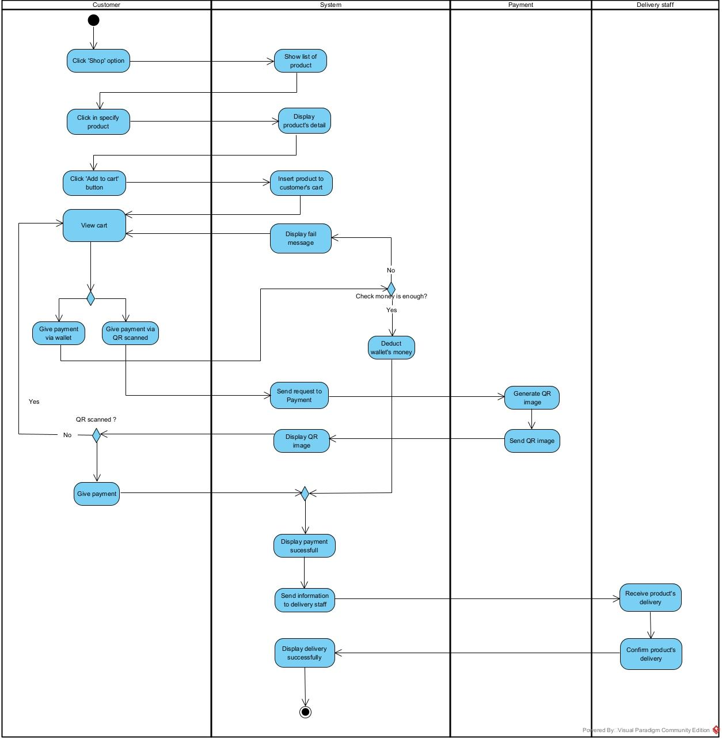

### 3.2 **Guest Login**



### 3.3 **Customer Add Fund To Wallet**

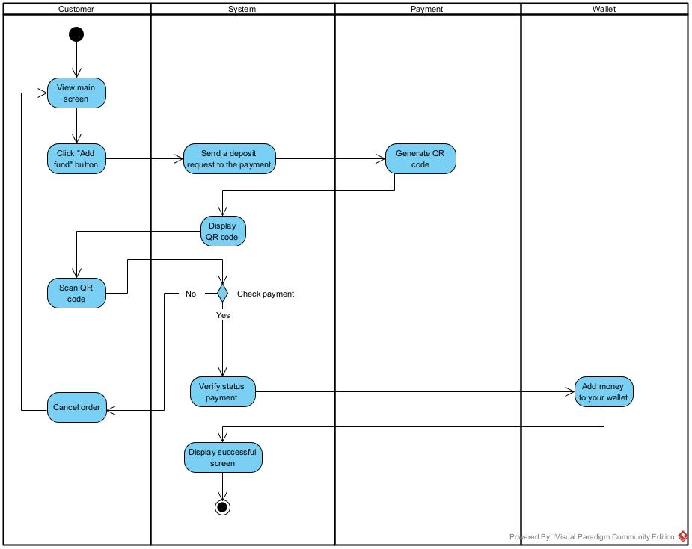

### 3.4 **Suppliers Add Category**



### 3.5 Full fill Rental Request



### 3.6 Check Out



### 3.7 View Order History



### 3.8 Update Rental Status



# IV. Appendix

## 1. Assumptions & Dependencies

AS-1:

Assumption: Users will have a stable internet connection to access all features of the system.

Rationale: The system heavily relies on cloud services, requiring users to always be connected to the internet.

AS-2:

Assumption: Third-party integration tools will be available for future development when integrating with services like PayPal or Stripe.

Rationale: Integration with third-party services may be required in future versions but is not planned for the initial release.

AS-3:

Assumption: The development team has sufficient resources to complete the core features of the system on time.

Rationale: To meet the product release deadline, the development team must focus on the main features without expanding into advanced features in the first version.

DE-1:

Dependency: The in-house payment gateway being developed must be secure and function efficiently to handle transactions.

Rationale: The system depends on building a secure in-house payment gateway to avoid the need for immediate third-party integration.

DE-2:

Dependency: Users must have modern browsers that support HTML5 to ensure the best user experience.

Rationale: The product is built with modern web technologies, requiring users to use compatible browser versions.

## 2. Limitations & Exclusions

LE-1:

Feature: Advanced Reporting and Analytics

Exclusion: The system will not include advanced reporting or detailed analytics dashboards for tracking user behavior, sales trends, or other complex metrics.

Rationale: Initial efforts are focused on providing a robust core experience, and advanced analytics will be considered for future releases based on user demand.

LE-2:

Feature: Multi-Language Support

Exclusion: The product will not support multiple languages and will only be available in English for the initial version.

Rationale: Supporting multiple languages requires significant development and localization efforts, which are outside the scope of the first release.

LE-3:

Feature: Offline Functionality

Exclusion: The product will not have offline capabilities, meaning users will need an active internet connection to access all features.

Rationale: The product heavily relies on cloud-based services, making offline functionality complex and costly to implement within the current timeline.

LE-4:

Feature: Customizable User Interface

Exclusion: Users will not be able to fully customize the interface, such as changing themes, layouts, or dashboard components.

Rationale: A standardized user interface ensures consistency and ease of use, with future versions potentially allowing for customization based on feedback.

LE-5:

Feature: Integration with Third-Party Payment Providers

Exclusion: The product will not integrate with third-party payment providers such as PayPal or Stripe for the first release.

Rationale: The focus is on developing a secure, in-house payment gateway. Third-party integration may be considered for future versions based on market demands.

LE-6:

Feature: Mobile Application

Exclusion: A dedicated mobile application for iOS and Android will not be available in the initial release.

Rationale: The initial focus is on optimizing the web-based experience, with plans for a mobile app to be explored post-launch based on user feedback.

LE-7:

Feature: Artificial Intelligence (AI) Features

Exclusion: The product will not include AI-driven features, such as chatbots, recommendation engines, or predictive analytics.

Rationale: AI features are beyond the scope of the current product roadmap and may be evaluated in future iterations based on demand and technological feasibility.

LE-8:

Feature: Custom APIs for Third-Party Integration

Exclusion: The product will not offer custom APIs to allow third-party services to interact with its functionalities in the first release.

Rationale: Developing and maintaining APIs requires additional resources and time, which is not prioritized for this version.

LE-9:

Feature: Self-Service Portal for Account Management

Exclusion: The product will not include a fully self-service portal where users can manage subscriptions, payments, and profiles independently.

Rationale: The focus is on streamlining the core experience, with customer support available to handle account management tasks manually for now.

## 3. Business Rules

| **ID** | **Category** | **Business Rule Description** |
| --- | --- | --- |
| BR-01 | Constraints | The Supplier must verify that the requested items are available before confirming the rental request. |
| BR-02 | Constraints | The Supplier must update the inventory to reflect the reservation of items. |
| BR-03 | Facts | The Supplier must communicate clearly with the Rental Agent and ensure accurate tracking of rental transactions. |
| BR-04 | Facts | The Supplier must log the rental transaction in the Activity Log or relevant tracking system. |
| BR-05 | Constraints | The Supplier must ensure that all responses are accurate and based on up-to-date information about products, services, or orders. |
| BR-06 | Facts | All queries and responses must be logged for tracking and auditing purposes. |
| BR-07 | Constraints | If a query requires escalation, the Supplier must follow the escalation process and notify the buyer of the status and expected resolution time. |
| BR-08 | Facts | The Supplier must follow up with the buyer if necessary to confirm resolution and satisfaction. |
| BR-09 | Constraints | The system must ensure that customers can only view their own order history. |
| BR-10 | Constraints | The system must ensure that the total rental or purchase amount is calculated correctly based on the selected items and their prices. |
| BR-11 | Constraints | The customer must receive a confirmation email with the rental or purchase details after the transaction is completed. |
| BR-12 | Constraints | The system must check the stock level of items before allowing the customer to add them to the cart. |
| BR-13 | Facts | The system must provide order tracking updates once the rental or purchase request is confirmed. |
| FR1 | Constraints | The system must validate that all required fields for adding a toy to the inventory are filled out. Required fields include toy name, category, price, and stock quantity. |
| FR2 | Constraints | User’s password must be encoded with MD5 hashing. |
| FR3 | Constraints | The system must ensure that duplicate toys are not added to the inventory. Before adding a new toy, the system should check for existing entries. |
| FR4 | Facts | The system must log each addition of a toy to the inventory in the Activity Log. This log should include details such as the toy's name, the date, and user. |

## 4. State Machine Diagram

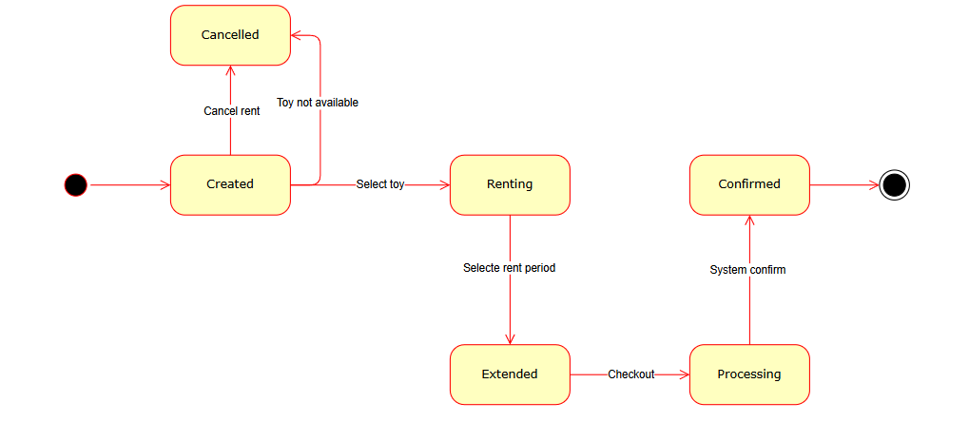

**Figure 1: Toy Rental Flow State Diagram**

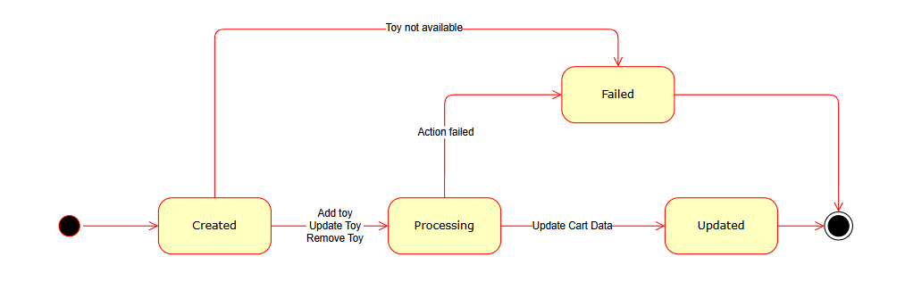**Figure 2: Cart Update State Diagram**

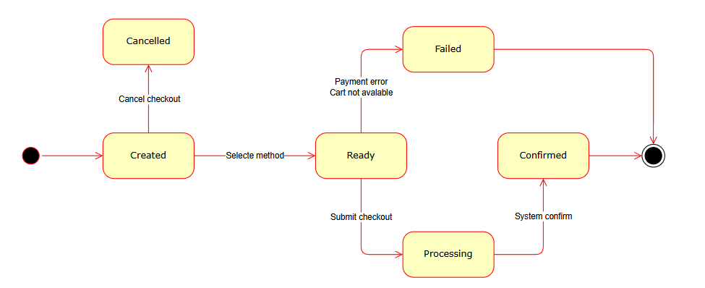**Figure 3: Checkout Process State Diagram 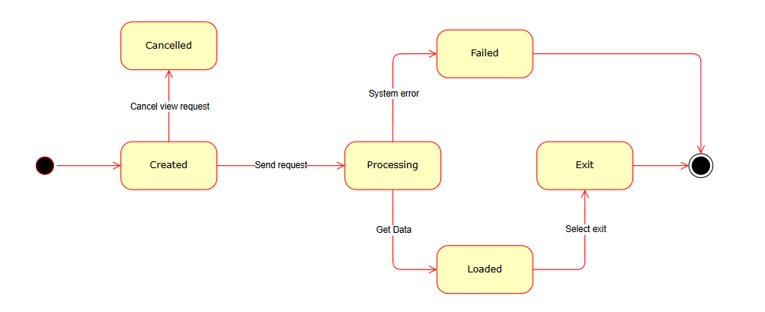Figure 4: Data Request State Diagram**

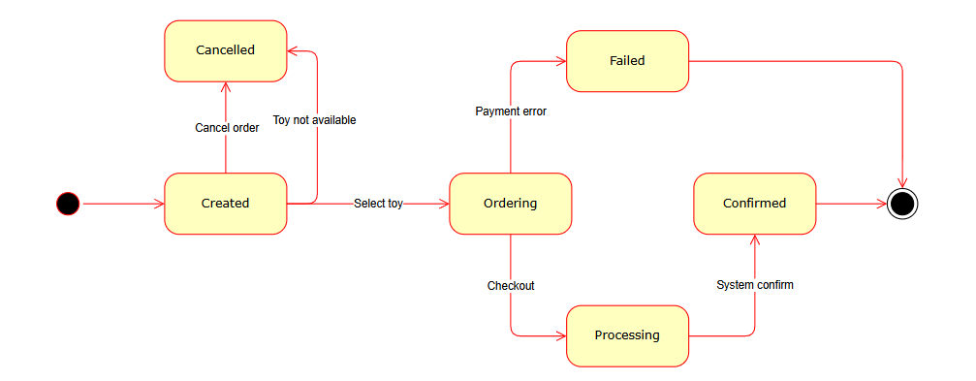**Figure 5: Order Process State Diagram**